Title of Paper Submitted to ICAF2019 <Times 10, regular>
<1 line>
First, Author ¹, Second Author ² <Times 10, regular, no title(s)>
¹Institute of Aviation, Warsaw, Poland <Times 10, italics>
²Air Force Institute of Technology, Warsaw Poland <Times 10, italics>
<3 lines>

The abstract should be written in one or two pages in reference to this format to describe objectives, results, conclusions, innovative steps and the significance of your work. It is encouraged to include several key figures and important references.
Prospective authors should submit their papers electronically.
Text of the summary. <Times 10, regular> The abstract should be written on regular 21 x 29.7 cm paper (A4) within a frame of 15 x 24.7 cm (margins left and right: 3 cm; top and bottom: 2.5 cm.). Use only original photos and illustrations, photocopies will not be accepted.
<1 line>
Table 1. Table captions should be placed above the table. <Times 10, italics>
<1 line>
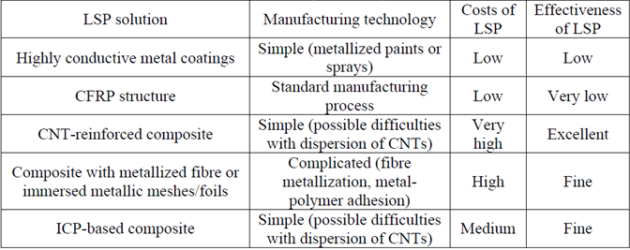
<1 line>
Tables should be numbered consecutively in Arabic numbers, independent of figures. Tables and captions should be left justified.
<1 line>
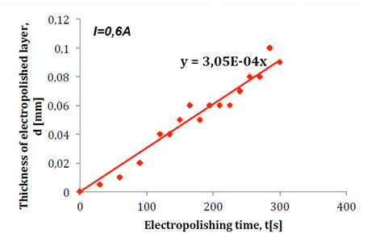
<1 line>
Figure 1. Figure captions should be placed under the figures. <Times 10, italics>
<1 line>
The term “figures” includes diagrams, line drawings, maps, pictures, etc. Figures should be numbered con-secutively in Arabic numbers, independent of tables.
<1 line>
Keywords: <Times 10, italics>

Abstract should be submitted in PDF file.

